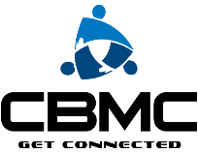 What is Your ‘Sphere of Influence’? Matt 28:16-20, Acts 1:8
- Who to ask to an outreach?
- Who to consider for your 10 most wanted card?
- Who to ask to try your CBMC team?
- Who to ask about Operation Timothy?
Relationship | Individuals | Actions
Church Friends,
other Christians you know; CBMC team members?
Members of your social clubs, Rotary, Lions, etc?
Neighbors,
Other parents from your children’s sports teams or Cub Scouts/Girl Scouts
Networking Partners, LeTip, BNI, BIB, etc?
Colleagues
Coworkers
other business owners?
Vendors, Doctors, Lawyer, Dentist, Accountant, Mechanic, Landscaper?
Customers, Prospects, Employees, Shareholders, Investors?
Other Gym members
Friends at the Coffee shop?
Mentors/Mentees?
Other members of boards you serve on?
Relatives, cousins, uncles, nephews, etc.

